**Aim 2: Employ an industrialized phage display platform to generate panels of recombinant antibodies that target up-regulated surface proteins in OS.**

**Subaim 2A.**Using high diversity Fab-phage and VH-domain phage libraries, we will generate antigens and select for antibodies to up-regulated targets (up to 6 targets) that are identified from OS surfaceomics.

**Subaim 2B.** Antibodies that bind specificly to target of interest (up to 24 antibodies) will be further converted into IgG for further testing. The top 6 antibody candidates will then be tested for tissue staining in tumor micro enviroment.

**SIGNIFICANCE**

We will focus on the use of *in vitro* selected recombinant antibodies as opposed to animal-derived monoclonal or polyclonal antibodies for several reasons. First, recombinant antibodies are sequenced cloned genes and thus renewable [5], [6]. The antibody genes can be further engineered for affinity or specificity if needed, and easily converted to different formats for both imaging and therapeutic purposes (e.g. Fab, IgG, antibody-drug conjugates, and gene fusions such as BITEs or Car-T-cells). In addition, *in vitro* selected antibodies are not biased against epitopes conserved in animals, making it more likely that they will achieve broader coverage. Moreover, phage display allows recombinant antibodies to be generated much faster, in a multiplexed fashion using robotics, with less antigen, and at lower costs than traditional monoclonal antibodies [7]. To facilitate generation of both antigen and antibodies, we developed a high throughput robotic platform for recombinant antibody generation by phage display, and demonstrated its power by generating high affinity antibodies for >500 chromatin remodeling proteins in cooperation with the recombinant antibody network (RAN) [7] (**Figure 2**). We have applied this platform to produce high affinity antibodies to about two dozen different surface proteins that are induced by oncogenic KRAS [8]. Targeting antibodies will be enabling reagents as biomarkers or as therapeutics by antibody directed cellular cytotoxicity (ADCC), antibody drug conjugate (ADC) or bispecific T-cell engagers (BiTE).

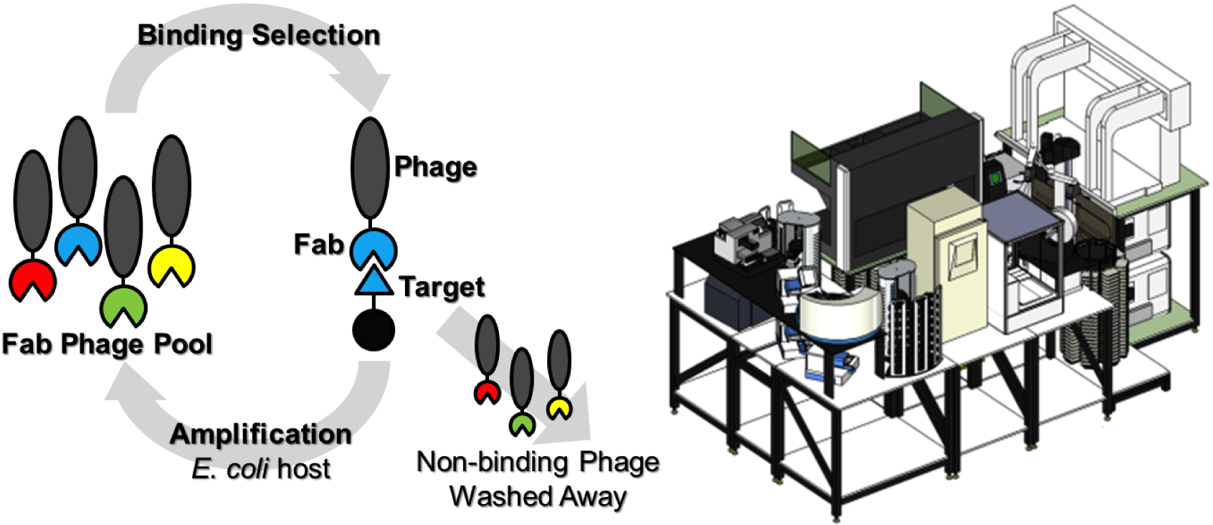

**Figure 2**. Phage display (left) and robotics at UCSF (right) to rapidly make recombinant antibodies.

**EXPERIMENTAL PLAN**

**Aim 2**. **Employ industrialized phage display platform to generate panels of recombinant antibodies to modulate targets up-regulated in tumor vasculature.**

We will nominate up to 6 candidate surface proteins from vascularture in tumor microenviroment for antibody generation. Candidate nomination will be based upon xxx. Although we anticipate finding a number of novel targets, we also expect some targets to have existing antibodies where we could simply clone and express published recombinant binders for further testing. We summarize our specific triage process below in **Figure 5**.

**Subaim 2A.**Generate antigens and select for antibodies using Fab-phage and VH-domain phage libraries.

1. *Generating soluble antigen for phage selections and cell displayed candidate extracellular proteins for antibody validation.*  Antigen quality is key to antibody selection for native epitopes [12]. To ensure glycosylation and native disulfide formation of our candidate targets, the extracellular domains are routinely expressed in human Expi293 cells as soluble secreted Fc-fusion proteins that are tagged for purification and immobilization on affinity resin for Fab-phage selections **(Figure 6A)**. Specifically, we will fuse the extracellular domain to an Fc domain to enhance secretion and solubility [13]. A biotin-acceptor Avi tag peptide is incorporated at the C-terminus to allow for site-specific biotinylation in cells and subsequent affinity capture of the soluble antigen for selections [14]. To this end, we developed a Expi293 cell line encoding a BirA biotin ligase localized to the endoplasmic reticulum for *in vivo* biotinylation of secreted proteins. We use this routinely for generation of antigens as fully biotinylated secreted protein. Furthermore, a tobacco etch virus (TEV) protease cleavage peptide [15] is incorporated between the antigen and Fc domain to facilitate selective release of antigen-bound Fab-phage during selections. We have successfully used this approach to generate Fc-fusion expression constructs for several hundreds of different extracellular domains as exemplified for candidate K-RAS and MYC-induced surface markers [2], [8]. We confirm the purity of the resulting Fc-fusion proteins by gel electrophoresis (**Figure 6B**). These proteins are produced routinely at high yield (~10µg per mL of culture), and can be produced in parallel.

***ii.* *phage display selection scheme.***For antibody selection, we employ our robotic phage display platform to generate and initially validate the recombinant antibodies (**Figure 2**)**.** Briefly, we use well-established Fab and VH libraries generated here at UCSF using codon biased mutagenesis of CDRs [16]. Both contain approximately 3-10x1010 unique antibody members with diversity primarily localized to the heavy chain CDRs (H1-H3) and the light chain CDR L3 in the case of Fab library [17]. These libraries are constructed on the highly stable trastuzumab scaffold (Tm ~80˚C), commonly used in pharma for humanization because it helps to avoid problems with denaturation and aggregation. These synthetic naïve libraries and derivatives have been successfully used to generate validated antibodies against >500 different transcription factors antigens [7], [16] and more than 200 surface antigens. Phage selections typically result in a pool of hundreds of Fab-phage or VH-phage for each antigen. These pools are then advanced for deconvolution and characterization based on unique sequence family, affinity and selectivity.

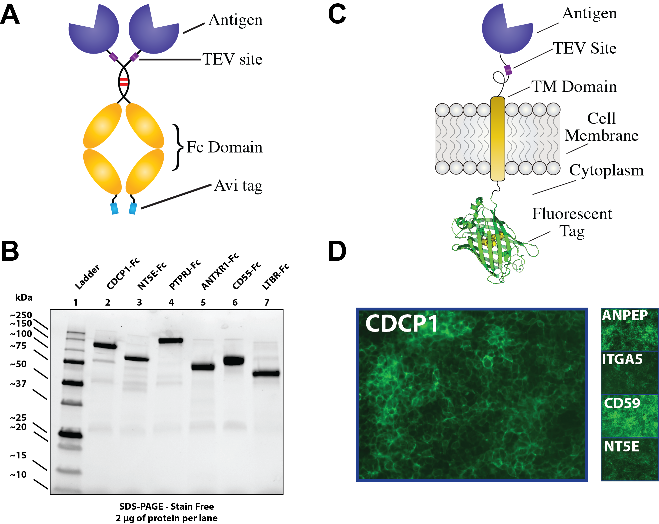

**Figure 6:** Antigen expression methods and preliminary data. (A) Schematic of the Fc-fusion expression construct. (B) Representative gel of purified Fc-fusion antigens.

***iii. Deconvoluting Fab-phage pools for affinity, selectivity and unique sequence.***We typically screen 96 Fab-phage clones in a conventional direct binding and competition phage-ELISA against the Fc-fusion antigen. All high affinity binders are sequenced to identify unique clones. We routinely obtain 5-10 unique Fab sequence families with high affinities for each target antigen (avg *K*d <10nM) [7].

***vi. Expression and biophysical characterization of top 5-10 Fab candidates****.* The lead Fab-phage clones are PCR amplified and subcloned into standardized *E. coli* expression plasmids, either Avi- or non-Avi-tagged, by ligase independent cloning methods (recombinant-antibodies.org/protocols). Expressed Fabs are secreted into the periplasm of *E.coli*, purified by Protein A affinity purification and generally yield 1-10 mgs of purified Fab per liter of culture [7]. An optimized and semi-automated pipeline will be utilized to characterize the affinities and specificities of the engineered Fabs. We typically measure IC50 by standard competition ELISA, and *Kd* using bio-layer interferometry (Octet RED384, ForteBio). The *K*d values for most of these antibodies are in the low nano-molar range (avg *K*d ~10nM), which is sufficient for the work planned**.** The Fabs are easily converted to IgGs by fusion to Fc domains. The bivalent IgG format typically produces a 10-100 fold improvement in binding affinity to membrane proteins by the well-known avidity effect. In the unlikely event that the lead Fab candidates or IgG conversions do not possess the sufficient affinity, we can conduct routine rounds of affinity maturation to improve Fab *K*d values to the picomolar range [19]. We routinely use size exclusion chromatography (SEC) to assess the solubility and triage antibodies prone to aggregation.

***v. Analyzing antibody specificity and validating antibodies as cellular imaging reagents.*** To evaluate Fab specificity on cells we will perform binding studies using immunofluorescence (IF) assays on cells engineered to display the parent target surface protein vs a decoy. Fabs are allowed to bind intact cells, and detected by staining with a protein A AlexaFluor546 conjugate. Only those Fabs that show co-localized binding with the cell-displayed cognate antigen, and not on the decoy cell line will be advanced. To further validate binding, we will perform flow cytometry staining on cells overexpressing the target of interest used in **Aim 1** from where the target was identified. Using this validation, we hope to identify up to 24 highly specific antibodies (up to 4 antibodies for each antigen) for further development into IgG.

**Caveats and alternative approaches:** Recombinant antigen expression can be a challenge for unstable proteins. If our standard antigen generation strategy proves inadequate for producing the full-length ectodomain suitable for selections, we will build alternative constructs by expressing subdomains informed by known or Alpha Fold predicted structure. Many membrane proteins contain IgG or FNIII like domains which can be stably expressed. In the cases where only low affinity antibody binders are found for a given antigen, we will proceed to construct affinity maturation libraries and perform selection campaigns for the most promising antibodies against the top targets. We also use these campaigns to improve the solubilities of candidate antibodies as needed.

**References**

[1] K. K. Leung, G. M. Wilson, L. L. Kirkemo, N. M. Riley, J. J. Coon, and J. A. Wells, “Broad and thematic remodeling of the surfaceome and glycoproteome on isogenic cells transformed with driving proliferative oncogenes,” *Proc. Natl. Acad. Sci. U. S. A.*, vol. 117, no. 14, pp. 7764–7775, 2020, doi: 10.1073/pnas.1917947117.

[2] W. Chen, K. Y. Mou, P. Solomon, R. Aggarwal, K. K. Leung, and J. A. Wells, “Large remodeling of the Myc-induced cell surface proteome in B cells and prostate cells creates new opportunities for immunotherapy.,” *Proc. Natl. Acad. Sci. U. S. A.*, vol. 118, no. 4, pp. 28046–28055, Jan. 2021, doi: 10.1073/pnas.2018861118.

[3] W. Chen, K. Y. Mou, P. Solomon, R. Aggarwal, K. K. Leung, and J. A. Wells, “Large remodeling of the Myc-induced cell surface proteome in B cells and prostate cells creates new opportunities for immunotherapy,” *Proc. Natl. Acad. Sci. U. S. A.*, vol. 118, no. 4, 2021, doi: 10.1073/pnas.2018861118.

[4] D. Hanahan and R. a Weinberg, “Hallmarks of cancer: the next generation.,” *Cell*, vol. 144, no. 5, pp. 646–74, Mar. 2011, doi: 10.1016/j.cell.2011.02.013.

[5] V. Marx, “Finding the right antibody for the job,” *Nat. Methods*, vol. 10, no. 8, pp. 703–707, Aug. 2013, doi: 10.1038/nmeth.2570.

[6] K. Colwill, Renewable Protein Binder Working Group, and S. Gräslund, “A roadmap to generate renewable protein binders to the human proteome.,” *Nat. Methods*, vol. 8, no. 7, pp. 551–8, May 2011, doi: 10.1038/nmeth.1607.

[7] M. Hornsby *et al.*, “A High Through-put Platform for Recombinant Antibodies to Folded Proteins,” *Mol. Cell. Proteomics*, vol. 14, no. 10, pp. 2833–2847, 2015, doi: 10.1074/mcp.O115.052209.

[8] A. J. Martinko *et al.*, “Targeting RAS driven human cancer cells with antibodies to upregulated and essential cell-surface proteins,” *eLife*, vol. 7, p. e31098, 2018, doi: 10.7554/eLife.31098.

[9] B. Wollscheid *et al.*, “Mass-spectrometric identification and relative quantification of N-linked cell surface glycoproteins.,” *Nat. Biotechnol.*, vol. 27, no. 4, pp. 378–86, Apr. 2009, doi: 10.1038/nbt.1532.

[10] H. Hanna, L. M. Mir, and F. M. Andre, “In vitro osteoblastic differentiation of mesenchymal stem cells generates cell layers with distinct properties,” *Stem Cell Res. Ther.*, vol. 9, no. 1, p. 203, 2018, doi: 10.1186/s13287-018-0942-x.

[11] J. D. Martell *et al.*, “Engineered ascorbate peroxidase as a genetically encoded reporter for electron microscopy,” *Nat. Biotechnol.*, vol. 30, no. 11, pp. 1143–1148, 2012, doi: 10.1038/nbt.2375.

[12] A. R. M. Bradbury, S. Sidhu, S. Dübel, and J. McCafferty, “Beyond natural antibodies: the power of in vitro display technologies,” *Nat. Biotechnol.*, vol. 29, no. 3, pp. 245–254, Mar. 2011, doi: 10.1038/nbt.1791.

[13] K. M. Lo *et al.*, “High level expression and secretion of Fc-X fusion proteins in mammalian cells.,” *Protein Eng.*, vol. 11, no. 6, pp. 495–500, 1998.

[14] U. Mechold, C. Gilbert, and V. Ogryzko, “Codon optimization of the BirA enzyme gene leads to higher expression and an improved efficiency of biotinylation of target proteins in mammalian cells.,” *J. Biotechnol.*, vol. 116, no. 3, pp. 245–9, Mar. 2005, doi: 10.1016/j.jbiotec.2004.12.003.

[15] D. A. Polayes, T. D. Parks, S. A. Johnston, and W. G. Dougherty, “Application of TEV Protease in Protein Production.,” *Methods Mol. Med.*, vol. 13, pp. 169–83, 1998, doi: 10.1385/0-89603-485-2:169.

[16] H. Persson *et al.*, “CDR-H3 diversity is not required for antigen recognition by synthetic antibodies,” *J. Mol. Biol.*, vol. 425, no. 4, pp. 803–811, 2013, doi: 10.1016/j.jmb.2012.11.037.

[17] P. Carter *et al.*, “Humanization of an anti-p185HER2 antibody for human cancer therapy.,” *Proc. Natl. Acad. Sci. U. S. A.*, vol. 89, no. 10, pp. 4285–4289, 1992, doi: 10.Carter, P., L. Presta, C. M. Gorman, J. B. Ridgway, D. Henner, W. L. Wong, A. M. Rowland, C. Kotts, M. E. Carver, and H. M. Shepard. 1992. “Humanization of an Anti-p185HER2 Antibody for Human Cancer Therapy.” Proceedings of the National Academy of Scie.

[18] C. J. Bracken *et al.*, “Bi-paratopic and multivalent VH domains block ACE2 binding and neutralize SARS-CoV-2.,” *Nat. Chem. Biol.*, vol. 17, no. 1, pp. 113–121, 2021, doi: 10.1038/s41589-020-00679-1.

[19] B. Luginbühl *et al.*, “Directed evolution of an anti-prion protein scFv fragment to an affinity of 1 pM and its structural interpretation.,” *J. Mol. Biol.*, vol. 363, no. 1, pp. 75–97, Oct. 2006, doi: 10.1016/j.jmb.2006.07.027.

[20] S. K. Elledge *et al.*, “Systematic identification of engineered methionines and oxaziridines for efficient, stable, and site-specific antibody bioconjugation.,” *Proc. Natl. Acad. Sci. U. S. A.*, vol. 117, no. 11, pp. 5733–5740, Mar. 2020, doi: 10.1073/pnas.1920561117.

[21] A. D. Cotton, D. P. Nguyen, J. A. Gramespacher, I. B. Seiple, and J. A. Wells, “Development of Antibody-Based PROTACs for the Degradation of the Cell-Surface Immune Checkpoint Protein PD-L1,” *J. Am. Chem. Soc.*, vol. 143, no. 2, pp. 593–598, 2021, doi: 10.1021/jacs.0c10008.

[22] L. J. Lahey *et al.*, “LRRC8A:C/E Heteromeric Channels Are Ubiquitous Transporters of cGAMP.,” *Mol. Cell*, vol. 80, no. 4, pp. 578-591.e5, 2020, doi: 10.1016/j.molcel.2020.10.021.

[23] K. Garber, “Bispecific antibodies rise again,” *Nat. Rev. Drug Discov.*, vol. 13, no. 11, pp. 799–801, 2014, doi: 10.1038/nrd4478.

[24] S. A. Lim *et al.*, “Targeting a proteolytic neo-epitope of CUB-domain containing protein 1 in RAS-driven cancer,” *bioRxiv*, p. 2021.06.14.448427, Jan. 2021, doi: 10.1101/2021.06.14.448427.

[25] K. Kato *et al.*, “Crystal structure of Enpp1, an extracellular glycoprotein involved in bone mineralization and insulin signaling,” *Proc. Natl. Acad. Sci.*, vol. 109, no. 42, p. 16876 LP – 16881, Oct. 2012, doi: 10.1073/pnas.1208017109.

[26] M. L. Dennis *et al.*, “Crystal structures of human ENPP1 in apo and bound forms.,” *Acta Crystallogr. Sect. Struct. Biol.*, vol. 76, no. Pt 9, pp. 889–898, Sep. 2020, doi: 10.1107/S2059798320010505.

[27] Z. B. Hill, A. J. Martinko, D. P. Nguyen, and J. A. Wells, “Human antibody-based chemically induced dimerizers for cell therapeutic applications,” *Nat. Chem. Biol.*, vol. 14, no. 2, pp. 112–117, Feb. 2018, doi: 10.1038/nchembio.2529.

[28] S. M. Gilbert *et al.*, “ATP in the tumour microenvironment drives expression of nfP2X7, a key mediator of cancer cell survival,” *Oncogene*, vol. 38, no. 2, pp. 194–208, 2019, doi: 10.1038/s41388-018-0426-6.

[29] J. A. Carozza *et al.*, “Structure-Aided Development of Small-Molecule Inhibitors of ENPP1, the Extracellular Phosphodiesterase of the Immunotransmitter cGAMP.,” *Cell Chem. Biol.*, vol. 27, no. 11, pp. 1347-1358.e5, 2020, doi: 10.1016/j.chembiol.2020.07.007.